Continuous Flow Measurement for RLCP Citizen Science

EA commonly measure discharge/flow at gauge stations equipped with only a telemetry-equipped (providing remote, real-time data) river level measuring device. The simplest form of river level measurement for citizen scientists is the staff gauge, and there are fixed, portable, even virtual options available (see document prepared for River Wensum Citizen Science program) for point-in-time measurement. However, to constantly measure discharge, continuous stream level needs to be measured.

First, it’s important to understand how EA (and others) get discharge (m3/s), a measurement of volume per unit time, from simple measurements of river level (m). The two key pieces of information that link these are water velocity (m/s), and cross-sectional area of the stream (m2).

*Equation 1.* Discharge *Q* (m3/s) = water cross-sectional area *A* (m2) x water velocity *V* (m/s)

Level (m) measurements, from a staff gauge or more complex instrumentation, only give one dimension of the two that are needed to have the cross-sectional area of water. However, if an accurate cross-sectional profile of the stream at the point of water level measurement is created, the cross-sectional area can be calculated from level, also called depth or stage, alone. The cross-sectional area of a stream is measured using equally-spaced points to measure the depth of water at step intervals along the width of the channel.

*Equation 2.* Water cross-sectional area *A* (m2) = Sum of [depth *D* (m) at each step x step width *W* (m)]

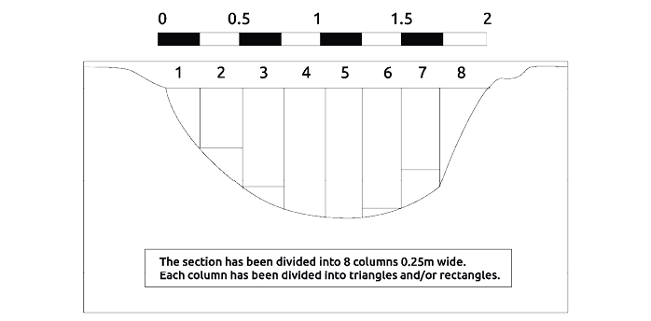

Figure 1 Stream cross-sectional profile from the [GeoPacks Flowmeter manual](https://indd.adobe.com/view/3c9664ae-ac20-43a2-9659-f7d68669d4bd), showing the constant step width W applied across the width of the channel, with vertical lines representing depth measurement points.

The accuracy of the cross-sectional area, and therefore discharge measurements derived from it, generally increases as the number of depth measurement steps increases (width of step decreases). The [GeoPacks Flowmeter manual](https://indd.adobe.com/view/3c9664ae-ac20-43a2-9659-f7d68669d4bd) provides an in-depth description of how to do this using a meter stick and a line stretched between the highest point of both banks, illustrated below. The manual also walks through how to calculate the cross-sectional area from the depth measurements at each step along the channel width.

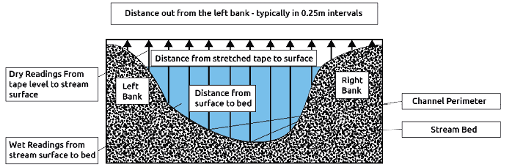

Figure 2 Measuring the stream channel cross-sectional profile, from [GeoPacks Flowmeter manual](https://indd.adobe.com/view/3c9664ae-ac20-43a2-9659-f7d68669d4bd),.

If all water flow is confined to the banks of the stream at the point of level measurement, the cross-sectional area of water in the stream can be derived from level measurements using the profile. If there is severe flooding with water flowing outside the banks, the cross-sectional area of water will be imprecise and any flow measurements derived from cross-sectional area should be viewed with caution due to underestimation of true peak flows. Furthermore, if heavy debris, plant growth, flooding, etc. changes the shape of the channel significantly, the cross-sectional area profile should be re-surveyed. Once or twice a year, as volunteer availability allows, the cross-sectional profile should also be re-surveyed to assure the quality of discharge measurements.

Returning to equation 1, we still need to know the velocity of the water flowing through the cross-sectional profile to calculate discharge. Flowmeters such as the GeoPacks Flowmeter can be used to measure this simultaneously as the depth measurements described above. Water velocity varies with depth and distance from the stream banks, so velocity measurements should be taken at the same step points as depth measurements used to measure cross-sectional area. This velocity is applied to each step of the cross-section such that discharge Q is calculated for each subsection of the cross-sectional profile, then summed to get the total discharge. Detailed instructions of how to measure velocity using a flowmeter are included in the [GeoPacks Flowmeter manual](https://indd.adobe.com/view/3c9664ae-ac20-43a2-9659-f7d68669d4bd).

*Equation 3.* Discharge Q (m3/s) = Sum of [cross-sectional area *a* (m2) per step x velocity *v* (m/s) per step]

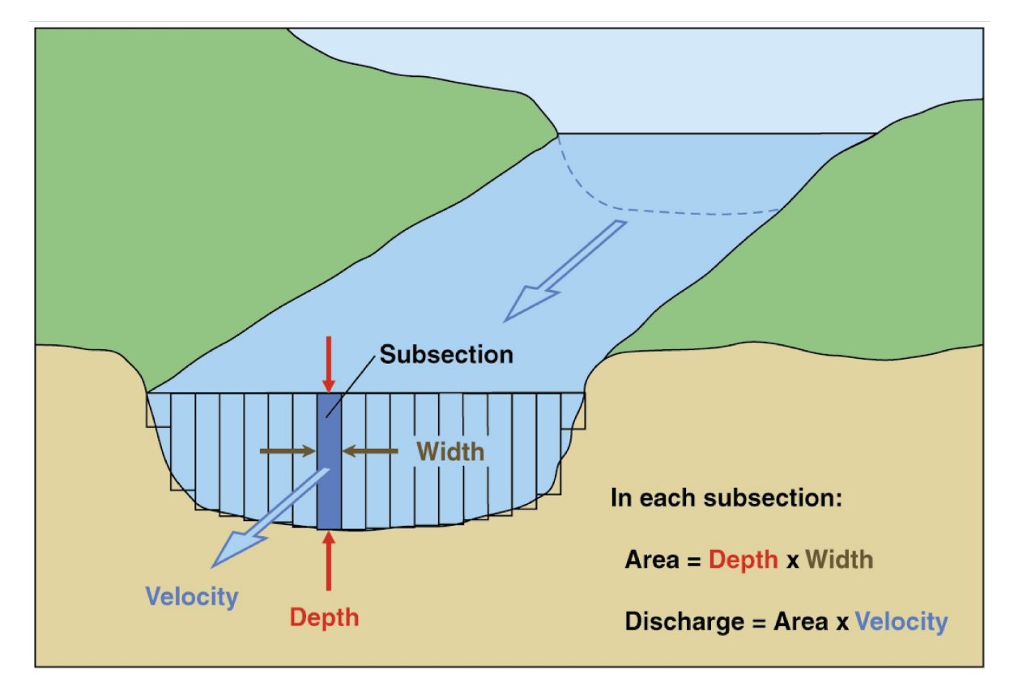

Figure Illustration of how discharge for the cross-sectional area is calculated using the velocity v (m/s) per cross-section step area (m2), from [USGS (public domain).](https://www.usgs.gov/media/images/diagram-channel-cross-section-subsections)

With the cross-sectional area *A* and water velocity *V*, citizen scientists can calculate discharge for a single point in time. If this measurement is repeated several times at different river levels, the relationship between level (stage) and discharge can be described, known as a stage-discharge (or rating) curve. The stage-discharge curve is how EA and others generate discharge measurements from river level measurements alone.

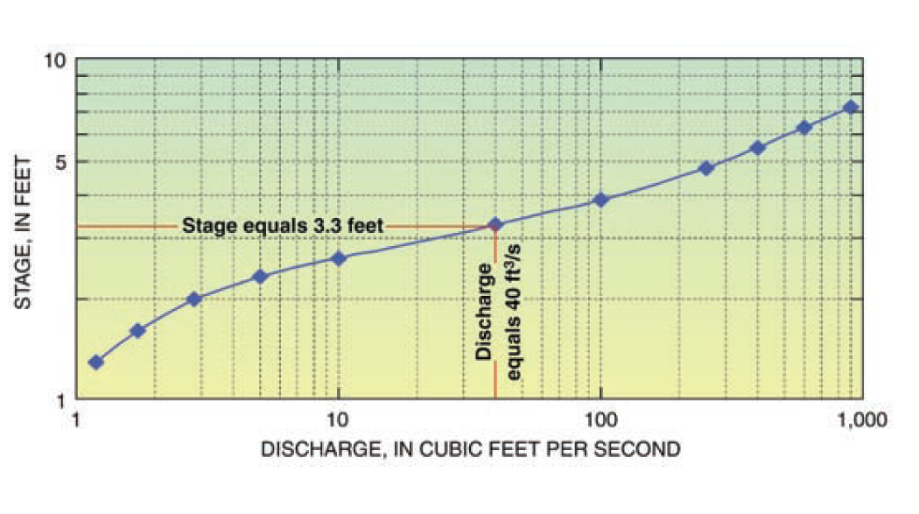

Figure Example of a stage-discharge curve, from [USGS (public domain)](https://www.usgs.gov/media/images/usgs-stage-discharge-relation-example).

Continuous river stage measurement can be accomplished using a submersible pressure transducer1 (per), such as the [HOBO water level logger](https://www.tempcon.co.uk/hobo-u20l-04-water-level-data-logger-0-4m) or the [Bell Flow Systems submersible level sensor](https://www.bellflowsystems.co.uk/submersible-level-sensor-vented-cable-4-20ma-0-200-mwg-see-ranges-.html?category_id=1521). While a staff gauge measures the physical depth of water, these level loggers measure the pressure exerted upon them by the water column to derive water depth1. Because the density of water depends on atmospheric pressure, which is not constant, this needs to be reconciled when calculating water depth from pressure measured by a sensor at the bottom of the stream, and the means of achieving this depend upon the style of level logger chosen1. “Vented” models, like the Bell Flow systems level sensor, can do this automatically because they have an air “vent” above the surface of the water2. “Unvented” models like the HOBO level logger require a second pressure transducer located nearby to compensate for the atmospheric pressure1. Many manufacturers, including HOBO, supply software that calculates the pressure-compensated depth when atmospheric pressure is known.

Submersible pressure transducers require on-site bases, which store the data transmitted from the sensors by a cable connection and must be compatible with the chosen transducer model. HOBO makes both [waterproof](https://www.measurementsystems.co.uk/u-dtw-1_hobo_waterproof_shuttle) and [water-resistant](https://www.measurementsystems.co.uk/base-u-4_optic_usb_base_station) base models, which can also be purchased in a [package](https://www.measurementsystems.co.uk/environmental-monitoring/water_leveltemp_logging/kit-s-u20-04-water-level-logger-starter-kit-4m?gclid=CjwKCAjw9NeXBhAMEiwAbaY4lj-5SPKMgPwmJ9PgQnq09jUM4nhF3_PQuwYwR0CgDEdCXqSh6wyH3BoC7gUQAvD_BwE) with the logger. Data is retrieved by connecting a laptop/similar device to the base via USB or Bluetooth. The pressure transducers also need to be protected from being carried off by floods or debris, which if bedrock/structural anchoring is not possible, is best achieved by installing the pressure transducer in a calm portion of the stream, (a pool of water within the stream is ideal)1. The sensor can be housed inside perforated PVC pipe or similar which is driven into the streambed as far as possible, using a post driver1. [Specialized protective housings](https://www.measurementsystems.co.uk/data-logging/battery_operated_data_loggers/software_and_accessories/HOUSING-U2X_Protective_Housing_for_U20_and_U24-Loggers) are also available for purchase but are essentially perforated PVC pipe. The surveyed stream cross-section used to create the stage-discharge curve should be relatively close to the level logger, but they do not need to be in the exact same location, as long as depth can be measured by the level logger the same day as instantaneous discharge measurement at the surveyed cross-section1. Changes in depth at the level logger location translate to changes in cross-sectional depth, and therefore discharge1.

1 Personal communication with Dr. Frank Wilhelm, University of Idaho.

2 YSI Inc./Xylem Inc. 2021. Water Level Measurement. Retrieved 12 Aug 2022. https://www.ysi.com/parameters/level